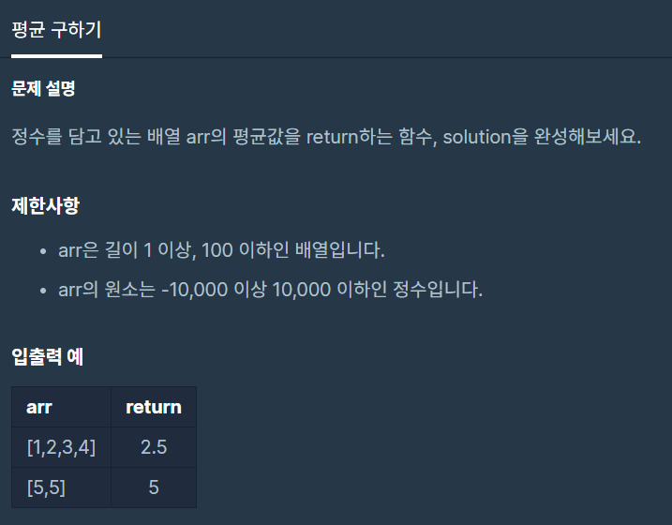

**문제 링크주소 :** <https://programmers.co.kr/learn/courses/30/lessons/12944>

**풀이**

function solution(*arr*) {

    var sum=0;

    for(var i=0; i<*arr*.length; i++){

        sum += *arr*[i]

    }

    return sum/*arr*.length

}

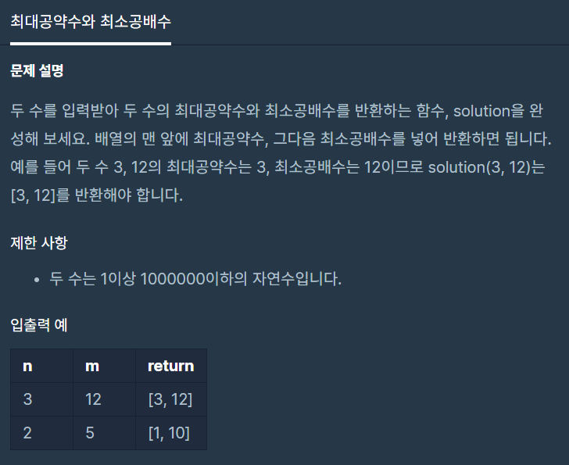

**문제 링크주소 :** <https://programmers.co.kr/learn/courses/30/lessons/12940>

**풀이**

function solution(*n*, *m*) {

    var answer = [];

    var minN = *n*;

    var minM = *m*;

    var maxN = *n*;

    var maxM = *m*;

    if(*n*<=*m*){

        while(minN>0){

            if((*m*%minN==0)&&(*n*%minN==0)){

                break;

            }

            minN--;

        }

        answer.push(minN);

        if(*m*%maxN==0){

            answer.push(*m*);

        }else{

            for(var i=1; i<=maxN; i++){

                if(*m*\*i%maxN==0){

                    answer.push(*m*\*i);

                    break;

                }

            }

        }

    }

    else{

        while(minM>0){

            if((*m*%minM==0)&&(*n*%minM==0)){

                break;

            }

            minM--;

        }

        answer.push(minM);

        if(*n*%maxM==0){

            answer.push(*n*);

        }else{

            for(var i=1; i<=maxM; i++){

                if(*n*\*i%maxM==0){

                    answer.push(*n*\*i);

                    break;

                }

            }

        }

    }

    return answer;

}